> head(max(average_acc_history$validation_acc))

[1] 0.9543677

> # Evaluate on Testset

> eval <- evaluate(model, test_data, test_targets, verbose = 1)

423/423 [==============================] - 2s 4ms/step - loss: 1.3329 - categorical_accuracy: 0.7621

> head(eval)

loss categorical_accuracy

1.332938 0.762109

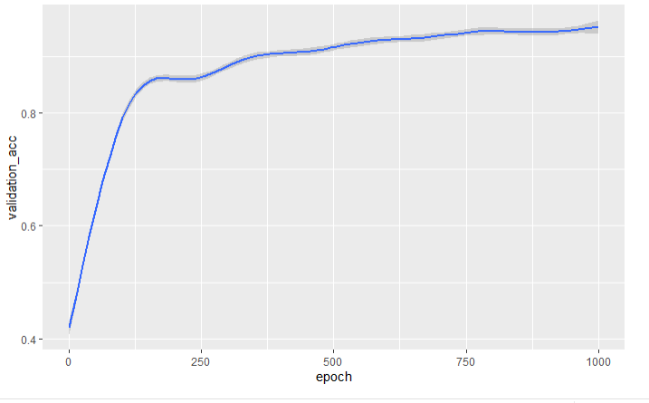

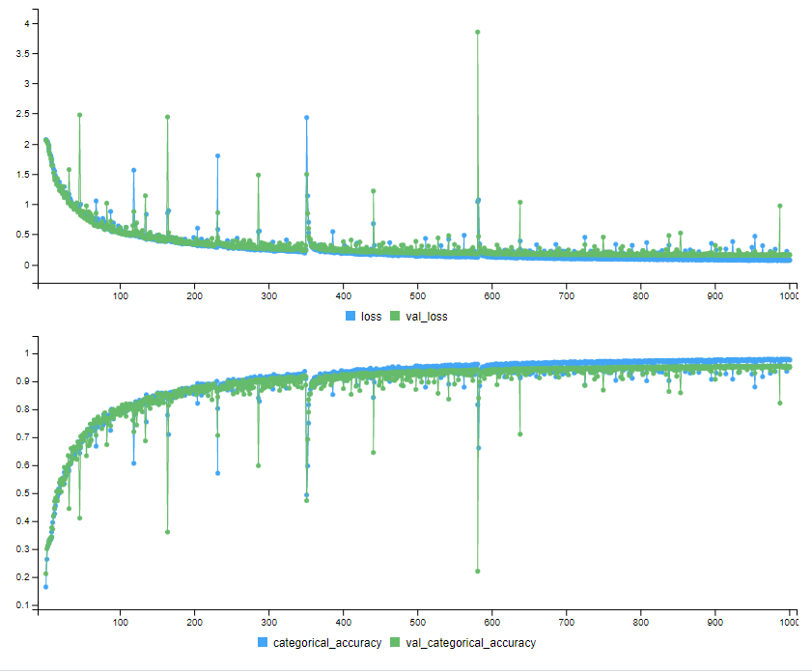

set.seed(5)

preprocRecipe <-

recipe(status ~., data = data) %>%

step_dummy(all_nominal(), -status, one_hot = TRUE) %>%

step_range(all_predictors(), -all_nominal(), min = 0, max = 1)%>%

step_smote(status, over_ratio = 1) %>%

# step_downsample(status, under_ratio = 1, skip=TRUE) %>%

# step_smote(status, over_ratio = 1, skip=TRUE) %>%

# step_smotenc(status, over_ratio = 1) %>%

# step_adasyn(status, over_ratio = 1) %>%

# step_nearmiss(status, over_ratio = 1) %>%

step_dummy(status, one_hot = TRUE)# %>%

Model:

# Function to build the model

build_model <- function() {

model <- keras_model_sequential() %>%

#layer_batch_normalization(axis = -1L, input_shape = dim(train_data)[[2]]) %>%

layer_dense(units = 128, activation = "relu", input_shape = dim(train_data)[[2]]) %>%

layer_dense(units = 128, activation = "relu") %>%

layer_dense(units = 128, activation = "relu") %>%

layer_dense(units = 128, activation = "relu") %>%

layer_dense(units = 128, activation = "relu") %>%

#layer_dropout(0.3) %>%

layer_dense(units = 8, activation = "softmax")

model %>% compile(

#optimizer = optimizer_sgd(learning_rate = 0.1),

optimizer = optimizer_adam(learning_rate = 0.1),

loss = "categorical_crossentropy",

metrics = "categorical_accuracy"

)

}